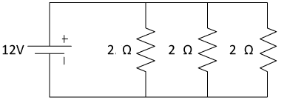
- COPY THE FOLLOWING CIRCUITS INTO YOUR NOTEBOOK AND FILL IN THE CHARTS
1-

 | V | I | R
1
2
3
TOTAL
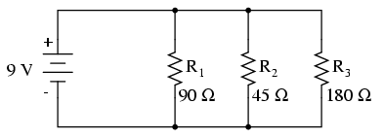
2-

 | V | I | R
1
2
3
TOTAL

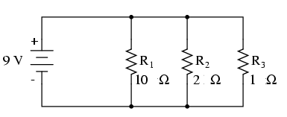
3-

 | V | I | R
1
2
3
TOTAL

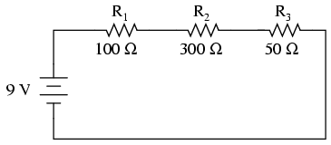
4-

 | V | I | R
1
2
3
TOTAL

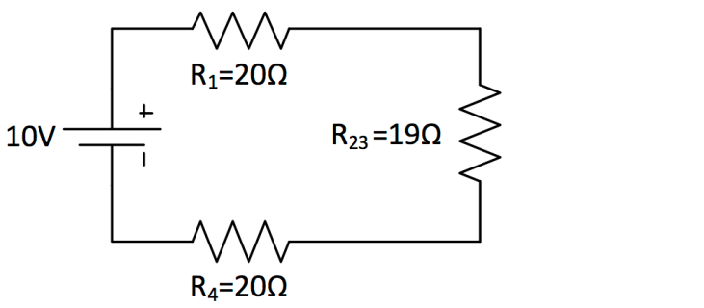
5-

 | V | I | R
1
2
3
TOTAL

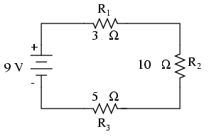
6-

 | V | I | R
1
2
3
TOTAL

